**Use excel file to update CS configuration in server**

**For Water meter**

1. Decide which device is changed CS configuration and the max and min value.

For example, **ID**= 00124B00010BD25B,**Max**=2226, **Min**=1611

1. Open “**Remote Ctrl code gengerator-R1.xlsx**”

Updated file can be downloaded at

<ftp://158.132.84.137//EnergySaving/Document/Configuration/CS>

1. Select “**W**” worksheet. It is for **water meter**.
2. Copy the ID name, Max and Min value to below location

ID ->**B8**

Max ->**H18**

Min -> **I18**

1. The excel auto generate three result at below location

**B1** ->**Ping comment**

**B2** ->**Configuration comment1**

**B3** ->**Configuration comment2**

**Ping comment** is used to test could the device receive you message. And the device will reply the message.

**Configuration comment1 and 2** are used to set the **CS configuration**.

Eg.

Configuration comment1 = FE1100124B00010BD25BC1000007E50002071873

Configuration comment2 = FE1500124B00010BD25BC1000408B20006064B0008000087

1. It is recommendedcopying those comments to a word file.
2. Connect to destination server. TeamViewer5 is often used to connect to the server. Please ask the ID and password form staff.
3. Login the server. Please ask the ID and password form staff.
4. Find  and double click it. It may be at desktop. Or it may be at

**desktop\PolyU MM\Tools\IEUMS Device Terminal\SerialPort Terminal.exe**

1. Then below window will be shown.

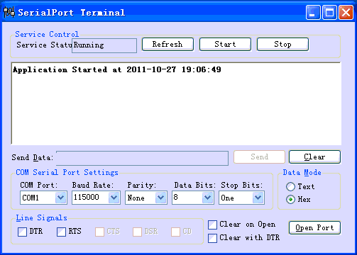

**12**

**13**

**11**

1. Click  to stop the service AleEventLogger. After that, Service Status become**Stopped**.
2. **Check Baud Rate** = 115000, **Parity** = None, **Data Bits** =8, **Stop Bits** = One, Date Mode “**Hex**” is selected.

**COM Port** is different at each site. If it do not be sured, please check below file

**C:\Program Files\PolyU MM\AleEventLoggerService\AleEventLoggerService.exe.config**

And then find the line like below

<add key=”COMPortNum” value=”**1**”/>

It means comport **1** is used.

1. Click  to open the COM port. The “Send Data” can be filled in value.
2. The values form the excel can be used now.
3. Copy value of “**Configurationcomment1**”. At **B2** in the excel. For example, “FE1100124B00010BD25BC1000007E50002071873”
4. Paste the value to “**Send Data**”.
5. Click .
6. Window will display value that you fill in.

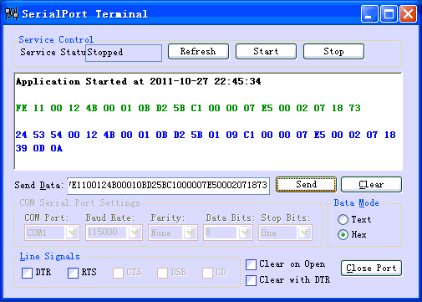

**17**

**16**

**18**

**19**

**23**

**24**

1. Wait for 10s. If the destination device receive the message, it reply something like

**24 53 54 … 0D 0A**

If not, the destination device does not receive anything and do not do any action.

If yes, it is success.

1. Copy value of “**Configurationcomment2**”. At **B3** in the excel. For example, “FE1500124B00010BD25BC1000408B20006064B0008000087”
2. Re-do the step 16~19. Then the CS configuration of one device has been set.
3. If more than one device is configured, do step 4~6 for all devices first. Then do step 7~14. And do step 15~21 until all devices have been set.
4. After all devices have been configured, click .
5. Remember click  to re-start the service AleEventLogger. Make sure Service Status is **Running** After click it.
6. Then click  close the program.
7. It is important job to check the service AleEventLogger running normally. Find and double click it to open pgAdmin. It may be at below address

**C:\Program Files\PostgreSQL\8.4\bin\pgAdmin3.exe**

1. Below window will be shown.

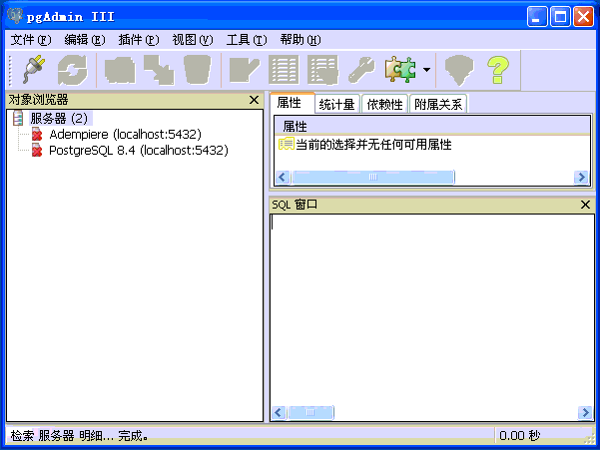

**28**

1. Double click 

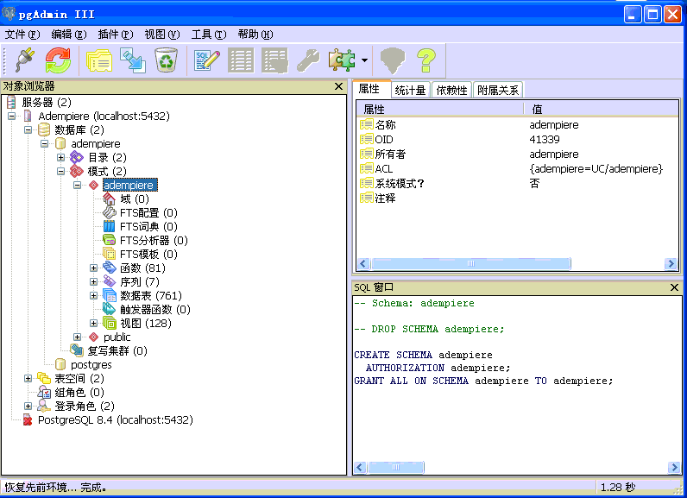

**29**

1. Click . Below window will be shown.

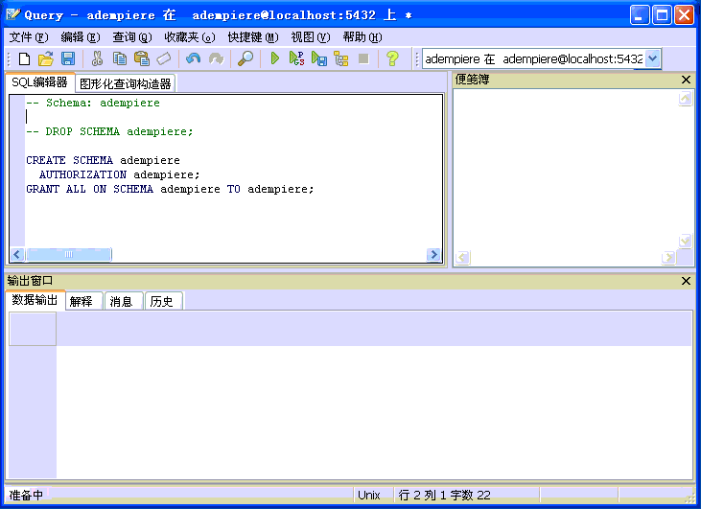

**30**

1. Del all word in 
2. Copy below commend to 

select *

frommm_log_meter

--where device_id like '%C7FE'

order by log_iddesc

limit 200

1. Click . Data will be shown as below.

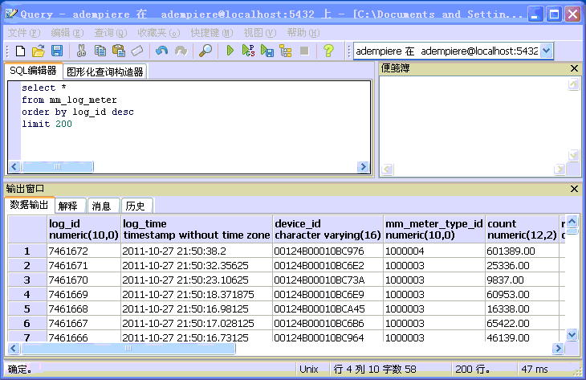

**33**

**32**

**31**

1. Check the time of update record in column 

If it is update, the service is running.

1. Re-click . If there are new records in the database, it is okay.
2. Close the program. And all is finish.